Assignment 2: Bootstrapping

Brad Anderson

February 23, 2018

Load Packages.

library(tidyverse)

## Loading tidyverse: ggplot2  
## Loading tidyverse: tibble  
## Loading tidyverse: tidyr  
## Loading tidyverse: readr  
## Loading tidyverse: purrr  
## Loading tidyverse: dplyr

## Conflicts with tidy packages ----------------------------------------------

## filter(): dplyr, stats  
## lag(): dplyr, stats

library(boot)

## Warning: package 'boot' was built under R version 3.4.3

library(nlstools)

##   
## 'nlstools' has been loaded.

## IMPORTANT NOTICE: Most nonlinear regression models and data set examples

## related to predictive microbiolgy have been moved to the package 'nlsMicrobio'

Create survey data vector and proportion function, then bootstrap.

survey <- rep(1:0, c(22,14))  
  
prop_fun <- function (x, i) {sum(x[i])/length(x[i])}  
  
boot_10000 <- boot(survey, prop_fun, R = 10000)  
boot_10000

##   
## ORDINARY NONPARAMETRIC BOOTSTRAP  
##   
##   
## Call:  
## boot(data = survey, statistic = prop_fun, R = 10000)  
##   
##   
## Bootstrap Statistics :  
## original bias std. error  
## t1* 0.6111111 -0.001161111 0.08115917

hist(boot_10000$t,  
 main="Histogram for UCSB Survey Bootstrap",   
 xlab="Percent that Experienced Negative Behavior",   
 border="white",   
 col="gray")

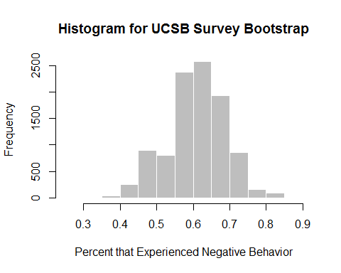

survey_ci <- boot.ci(boot_10000, conf = 0.95, type = "perc")  
survey_ci

## BOOTSTRAP CONFIDENCE INTERVAL CALCULATIONS  
## Based on 10000 bootstrap replicates  
##   
## CALL :   
## boot.ci(boot.out = boot_10000, conf = 0.95, type = "perc")  
##   
## Intervals :   
## Level Percentile   
## 95% ( 0.4444, 0.7778 )   
## Calculations and Intervals on Original Scale

The mean percent of genderqueer students who responded that they had personally experienced “exclusionary, offensive, hostile or intimidating conduct” is 61% (n =36), with a bootstrapped 95% confidence interval of [0.44, 0.7778] tons (10,000 bootstrap samples).